Exploring Dissolved Organic Matter Characteristics Across the Coastal Terrestrial-Aquatic Interface

Julia McElhinny

The coastal terrestrial-aquatic interface (TAI), where nearshore terrestrial and coastal aquatic ecosystems meet, is a significant biogeochemical hot spot. Hydrologic flow through TAI soils, especially during precipitation events and tidal extremes, leads to the delivery of terrestrially derived materials to waterways, where microbes can rapidly process this dissolved organic matter (DOM). Previous research demonstrates that watershed-level landscape features such as topography, soil type, land cover, and hydrology are strongly related to coastal aquatic DOM concentration and composition. However, less is understood about the biogeochemical processing that occurs during soil DOM transport and how this impacts the DOM in adjacent waters. To estimate which DOM pools could be exported to coastal waters and how DOM is transformed across the TAI gradient (from upland forests to wetlands), we extracted water-soluble organic matter (WSOM) from Great Lakes, Chesapeake Bay, and Delaware Bay soils at ten different sites. We measured WSOM concentration and composition and compared the metrics with those of nearby surface water DOM. We found that soil WSOM concentrations across the TAI gradient are not significantly different, but WSOM composition changed systematically from upland soils to coastal waters. This suggests that there are linkages in WSOM across the coastal TAI in our study regions.

INTRODUCTION

The coastal terrestrial-aquatic interface (TAI) is a highly dynamic zone that plays an active role in many global biogeochemical cycles, especially the carbon cycle1–3. Despite only occupying small spatial extent globally, coastal blue-carbon ecosystems at this interface, which include salt marshes and tidal forests, sequester and process a disproportionate amount of carbon and other organic matter2,4. These coastal zones are significant biogeochemical hot spots5,6, where hydrologic flow, either due to tidal influence or precipitation events, controls the connectivity of different reactant pools and thus the rate and processing of organic matter3,7,8 especially dissolved organic matter (DOM).

DOM is the most mobile component of OM9–11, and thus, its availability and distribution throughout soils is one of the largest regulators of microbial activity12,13. Much of the DOM in inland waters originates from terrestrial landscapes14,15, and these fluxes can be both beneficial and detrimental to aquatic ecosystems by driving aquatic primary production16, yet can also alter the availability of light and oxygen at higher concentrations17. DOM also has a large influence on the establishment and maintenance of soil carbon pools because when DOM is transported from terrestrial to aquatic ecosystems, this represents a loss from carbon sinks in terrestrial ecosystems13. This loss is presently estimated at 1.9 Pg C but has been historically underestimated due to knowledge gaps in understanding the processing of organic matter than occurs at the TAI15,18. Soils contain more carbon than the atmosphere and vegetation combined19,20 at an estimated 2500 Pg, which, if altered through changes in OM fluxes, can greatly impact the terrestrial carbon balance with great implications for Earth’s climate21,22. Continued refinement of the value of this flux from terrestrial ecosystems to inland waters will also allow for more accurate determination of ecosystem net primary productivity (NPP)23. Recent research has suggested that up to 15% of the estimated global NPP could be exported as dissolved organic carbon (DOC) to aquatic ecosystems24, making it important to constrain values for ecosystem export so that the true carbon storage capacity of terrestrial primary producers can be better represented in current global carbon cycle models15,25.

To increase understanding of DOM inputs to aquatic ecosystems, focused investigation of the relationship between aquatic DOM characteristics and numerous environmental variables, ranging from specific soil processes to larger scale ecosystem characteristics14, has been conducted. Previous studies have demonstrated that higher levels of stream discharge from forests are correlated with higher DOM concentrations in connected catchment areas, as heavy precipitation increases hydrological connectivity between soils and receiving waters10,26,27. Differences in land cover and land use28–30 as well as in soil type31 have been shown to drive differences in the concentration and composition of DOM fluxes across ecosystem types. Various soil characteristics have been related to DOM release from terrestrial ecosystems; for example, soil C:N ratio32, soil pH33,34, composition and activity of soil microbial communities35, and soil clay and metal ion concentrations34 all control the size and composition of the DOM pool available for transport.

Because soil DOM is difficult to collect without intensive and invasive field methods (e.g., lysimeters), water soluble organic matter (WSOM) is frequently extracted from soils in a laboratory setting36,37 to roughly represent the potential mobile DOM fraction that could be released and transported with increased hydrologic flow38. In place of correlation-based studies that indirectly link large scale, landscape-level watershed characteristics to aquatic DOM characteristics, WSOM has been used to highlight the direct effects of these very same landscape characteristics on the soil DOM pool12,36,39. However, few studies have utilized WSOM to understand the biogeochemical processes and mechanisms underlying DOM transport, especially in coastal regions38,40.

Here, to investigate the provenance and biogeochemistry of DOM potentially transported from TAI soils potentially to aquatic ecosystems across two major coastal regions, we extracted WSOM from soils across the TAI gradient (from uplands to wetlands) and compared WSOM concentration and composition to that of the DOM collected in adjacent surface waters. We explored the relationships in composition to understand potential connectivity across the TAI gradient and potential sources of aquatic DOM.

METHODS

Study Sites

Members of the EXCHANGE consortium (Exploration of Coastal Hydrobiogeochemistry Across a Network of Gradients and Experiments, a sub-activity of COMPASS[1]) collected soil and water samples at 52 sites at the terrestrial-aquatic interface (TAI) across the Great Lakes and US Mid-Atlantic regions. Ten of these sites were chosen semi-randomly for soil DOM extractions, aiming to represent a range of environmental conditions (e.g., geographic location, salinity, soil type). Three sites were chosen from the Great Lakes region and the remaining seven from the US Mid-Atlantic region, which encompasses the Chesapeake Bay and the Delaware Bay (Fig. 1).

FIG. 1. Location of study sites on the Great Lakes, Chesapeake Bay, and Delaware Bay. All sites are located at the coastal terrestrial-aquatic interface.

Sample Collection and Preparation

At each of the ten study sites, soils were collected at three sample locations across the TAI gradient: upland, transition, and wetland (Fig. 2). Soils were collected from the top 5 cm of the soil profile, and subsamples used in this analysis were frozen (-20°C) before they were freeze-dried, sieved to 5.6mm, and then ground to a fine particle size in a ball mill or with mortar and pestle. These processed soils were stored at room-temperature in clear plastic jars until analysis.

Surface water samples were collected at each of the study sites into vials using 0.22 µm Sterivex syringe filters. Samples were kept refrigerated at 4°C until analysis.

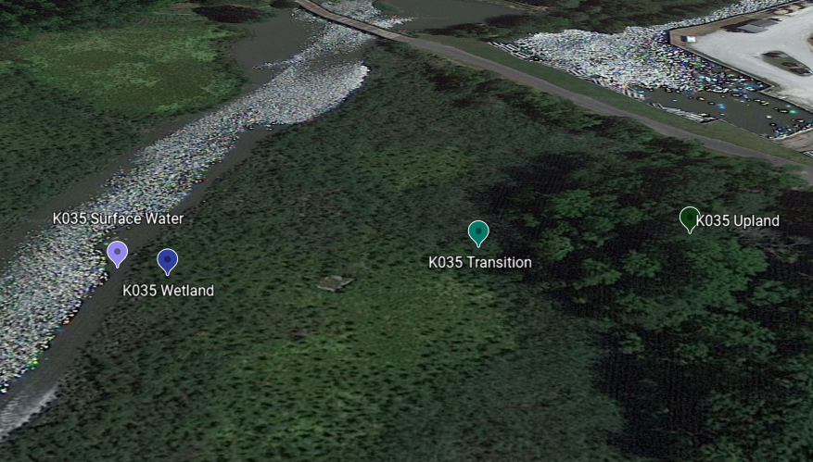

B.

A.

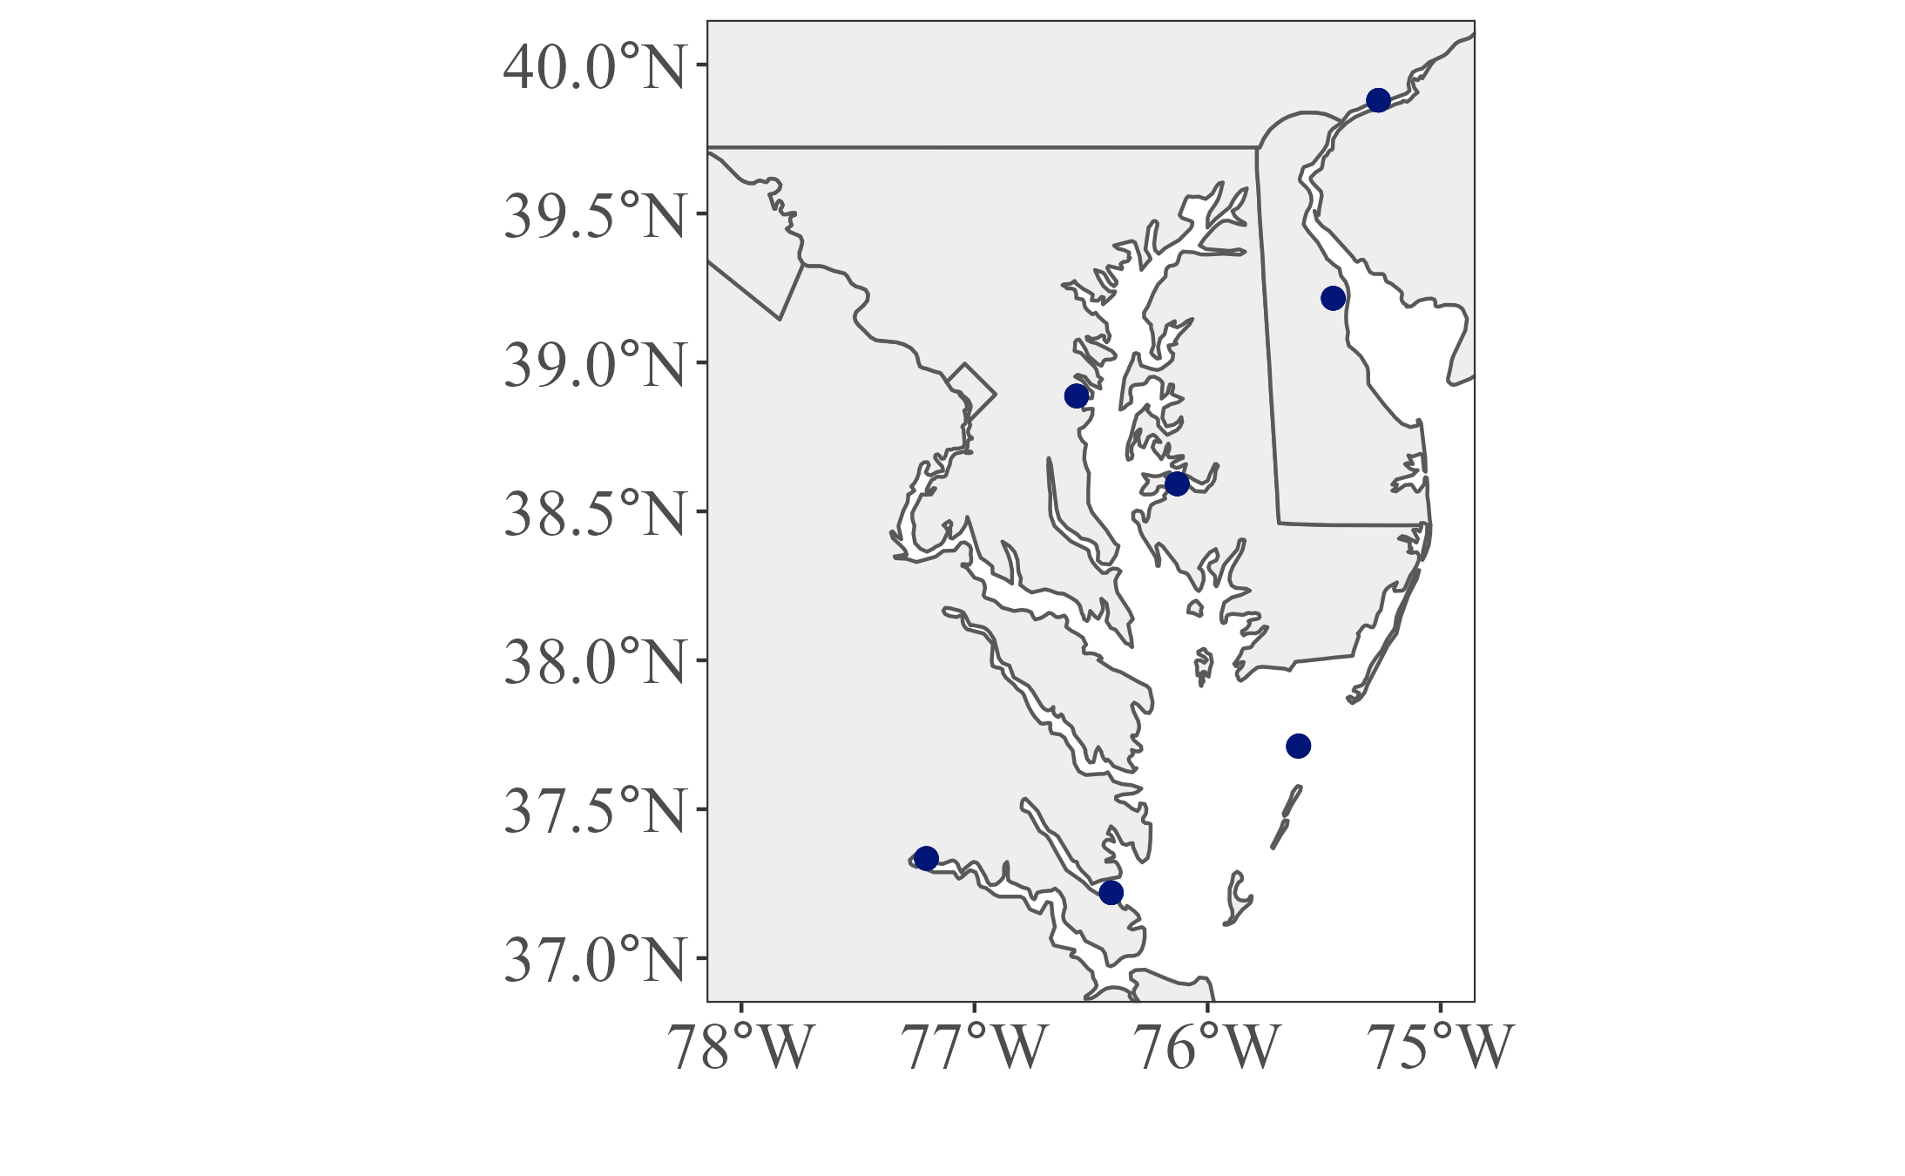

FIG. 2. Location of three soil sample locations across the TAI gradient (upland, transition, and wetland) and the surface water collection site at one of the ten study sites (Panel A). This study site’s general location is indicated by an orange box in panel B. Image generated in Google Earth ver. 9.177.0.1.

WSOM Extraction Procedure

Processed soil samples were weighed into 50 mL conical centrifuge tubes, and MilliQ water was added, adhering closely to a 1:5 soil-to-water ratio by mass. After allowing the water to fully saturate the soil, the samples were placed horizontally on a shaker table (Thermo Scientific MaxQ 6000) and shaken for 1 hour in the dark at 200 rpm at 21°C to ensure sufficient contact between the water and soil. Samples were then immediately centrifuged (Eppendorf 5430 R) for 15 minutes at 7000 rcf at 21°C.

Taking care to not disturb the pellet, the supernatant of each sample was drawn into a 60 mL sterile syringe (Fisherbrand) using acid-washed, cut pieces of 1/8 inch PTFE tubing. The supernatant was filtered through 0.45 µm PES syringe filters (Thermo Scientific Choice) into pre-combusted 40 mL amber vials. For each sample, syringe filters were exchanged for fresh ones when the constant pressure applied to the syringe barrel was unable to maintain a steady stream of filtered extract (i.e., when the flow changed to droplets as the filters became clogged). Filtered extracts were stored at 4°C until further analyses.

Instrumental Analyses

Filtered WSOM extracts and surface water samples were analyzed for NPOC (non-purgeable organic carbon) on a Total Organic Carbon Analyzer (Shidmadzu TOC-L). To ensure that measurements fell within the range of the instrument’s calibration curve, all WSOM extracts were diluted prior to the instrument run.

Water-soluble organic carbon (WSOC) concentrations were reported in mg/g dry soil by normalizing reported concentrations (*NPOC*, mg/L) to the volume of MQ water (*VMQ*, L)and mass of soil (*Msoil,* g) used during extraction (Equation 2), following the normalization methods used by Wardinski et. al.38 The volume of MQ water used was calculated based on the mass of the MQ water added to the centrifuge tubes (*MMQ,* g) (Equation 1).

|  |  |  |
| --- | --- | --- |
|  | where = 997.77 g/L | (1) |

|  |  |  |
| --- | --- | --- |
|  |  | (2) |

WSOM extracts and surface water samples were analyzed for absorbance and fluorescence simultaneously on an Aqualog (Horiba Scientific). Both absorbance data and fluorescence excitation-emission matrices (EEMs) were collected from 230 to 800 nm in 3 nm intervals. EEMs were blank-corrected, dilution-corrected, Raman normalized, and corrected for inner-filtering effects during post-processing using drEEM toolbox v. 6.0 ([www.openfluor.org](https://pnnl-my.sharepoint.com/personal/julia_mcelhinny_pnnl_gov/Documents/Documents/SULI%20Project%202022/Deliverables/www.openfluor.org))41 in Matlab v 2020b.

After post-processing, several spectral metrics were calculated following conventional methods to provide information about organic matter characteristics42: Specific UV Absorbance at 254 nm (SUVA254)43, spectral slope from 350 to 400 nm (*S*350-400)44, freshness index (FRESH)45, humification index (HIX)46, and fluorescence index (FI)47.

Statistical Analyses

All statistical analyses were performed in R ver. 4.2.1 (R Core Team, 2022). WSOC concentrations were natural log transformed prior to using a two-way analysis of variance (ANOVA) to determine if mean concentrations were significantly different between TAI gradient locations and between study regions.

Differences in mean spectral metrics between gradient locations were evaluated using nonparametric Kruskal-Wallis tests followed by pairwise post-hoc Dunn tests, adjusting p-values with the Holm method. After normalization, the five calculated spectral metrics were used in a principal components analysis (PCA) to visualize groupings of organic matter samples (both WSOM extracts and surface waters) by compositional characteristics.

RESULTS

WSOC/Surface Water DOC Concentrations

WSOC concentrations in both the Great Lakes and Mid-Atlantic regions on average decreased slightly from upland to transition gradient locations and then increased slightly from transition to wetland gradient points (Table 1, Fig. 3a). Concentrations between regions and between gradient locations were not significantly different (*F*(2,24) = 0.439, p-value = 0.65; *F*(1,24) = 0.497, p-value = 0.488), and there was not a significant interaction between the effects of region and gradient location (*F*(2,24) = 0.034, p-value = 0.967).

Surface water DOC concentrations in the Lake Erie region were much higher than those that of the Mid-Atlantic region (Table 1, Fig. 3b).

B.

A.

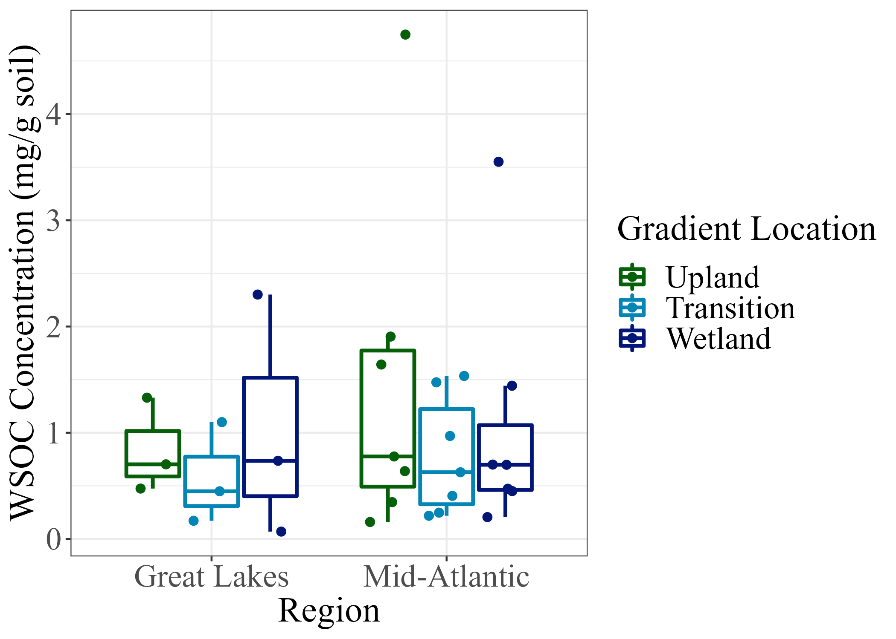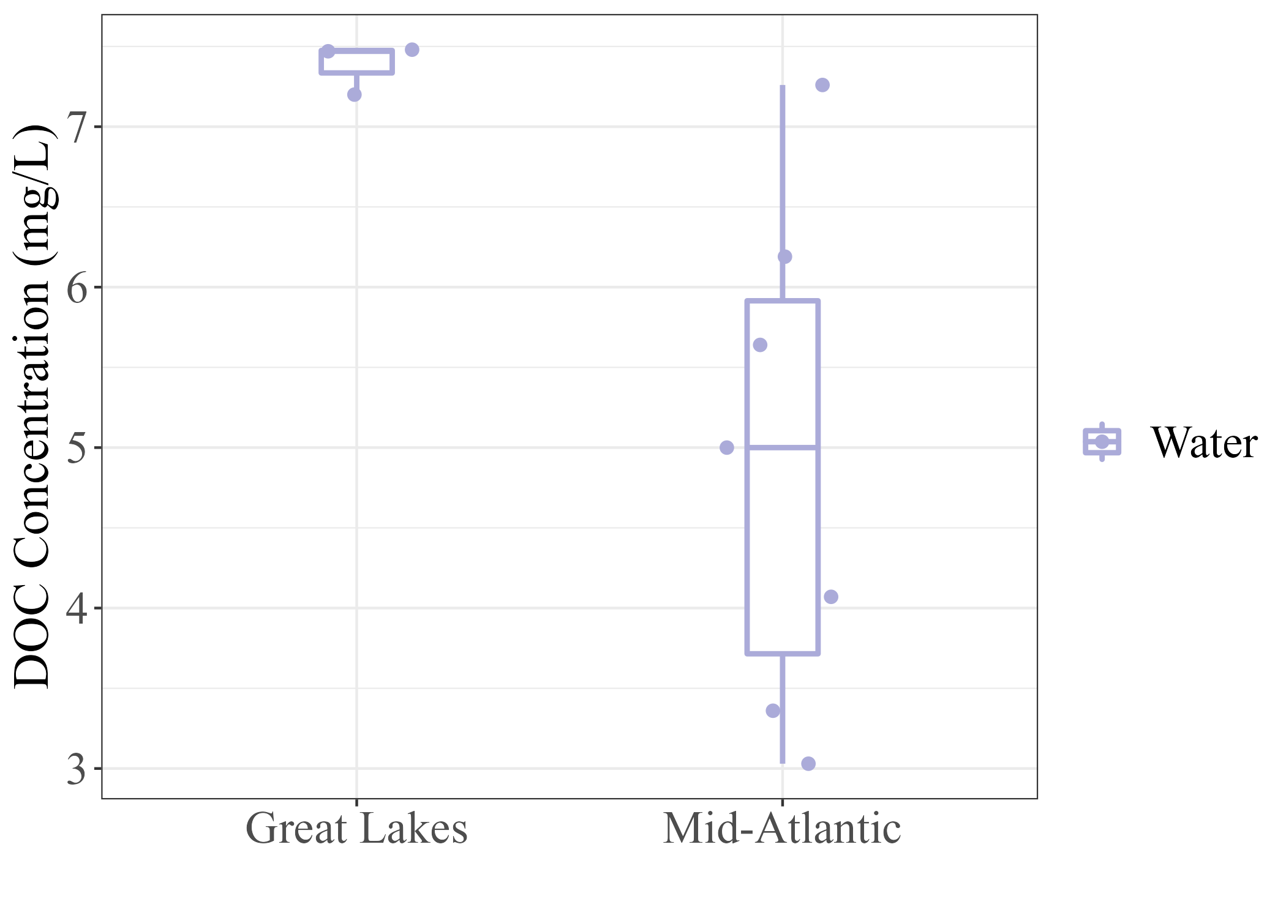

FIG. 3. A) Water soluble organic carbon (WSOC) concentration (in mg/g dry soil) grouped by study site region and gradient location (indicated by the color of the boxplot outline). B) Surface water dissolved organic carbon (DOC) concentrations in mg/L, grouped by study site region.

WSOM/Surface Water DOM Composition

SUVA254 values at the upland and transition TAI gradient locations were generally equal, exhibiting no statistically significant difference (Table 2, Fig. 4a). Values of SUVA254 were significantly lower at wetland sites and significantly higher in surface waters relative to values at upland and transition sites. The opposite pattern was observed for *S*350-400 values; this value increased gradually moving from upland to wetland sites, but the average *S*350-400 value for surface waters was significantly lower than those of the other locations (Table 2, Fig. 4b).

FI values increased from upland to wetland sites, and the average surface water FI was not significantly different from that of the wetland site but was significantly different from both upland and transition sites (Table 2, Fig. 4c). FRESH values also generally increased along the gradient from upland to surface water, with similar values at upland and transition sites that were significantly different from those of wetland sites and surface waters (Table 2, Fig. 4d). HIX values were consistent across the three soil gradient locations; however, the average HIX value of surface waters was significantly lower than those of the other locations (Table 2, Fig. 4e).

In the PCA representing the organic matter composition of all samples based on the values of the five calculated spectral metrics, composition showed a marked contrast between surface waters and WSOM extracts along PC1. The composition of upland sites was also distinctive from that of wetland sites along PC2, and the composition of transition sites displayed overlap with both wetland and upland sites. The first and second principal components (PC1 and PC2) explained 45.7% and 26.76% of the total variance, respectively (Fig. 5).

FIG. 4. Spectral metrics of water soluble organic matter extracts and surface water dissolved organic matter, grouped by gradient location: A) Specific UV Absorbance at 254 nm (SUVA254), B) spectral slope from 350 to 400 nm (*S*350-400), C) Fluorescence Index (FI), D) Freshness Index (FRESH), and E) Humification Index (HIX). Levels of significance for differences in spectral metrics between gradient locations based on the results of pairwise post-hoc Dunn tests are indicated; * corresponds to p-value < 0.1, ** to p-value < 0.05, *** to p-value < 0.01, **** to p-value < 0.001, and ***** to p-value < 0.0001.

FIG. 5. Principal components analysis scores for DOM composition of WSOM extracts and surface waters across four gradient locations (point color) and two different regions (point shape). The loadings of the five calculated spectral metrics (SUVA254, *S*350-400, FI, FRESH, HIX) are shown with SUVA254 corresponding to SUVA254 and S350_400 corresponding to *S*350-400.

*Note: Colored frames also correspond to gradient location and are intended to help visualize the distinct characteristics; they are not the result of any formal cluster analysis.*

DISCUSSION

WSOC Concentration is Not Determined by TAI Gradient Location

Across both the Great Lakes and the Mid-Atlantic regions, location along the TAI gradient had no significant impact on WSOC concentration in WSOM extracts. However, location along the TAI gradient also had no significant impact on soil total carbon percentage (Appendix; Fig. 6). Given that WSOC is highly correlated to both total soil organic carbon (SOC) and soil total carbon (TC)48,49, it is reasonable that for our sample sites, based on trends in total carbon percentages, we would not expect to see a gradient-dependent change in WSOC concentrations. These observations are consistent with prior WSOM research along the TAI gradient38.

As suggested by previous studies, soil depth plays a more significant role in determining TC, SOC, and WSOC concentrations as deeper soil horizons are the site of higher levels of carbon storage38,50. Therefore, it is possible that sampling different soil horizons at our study sites across the gradient would have revealed that depth, but not TAI gradient location, had a significant impact on WSOC concentrations.

It is important to note that although WSOC concentrations are approximately equal across study site regions, DOC concentrations in surface waters are not, with the Great Lakes region having a much higher concentration (Fig. 3b). This implies that WSOC concentrations of nearby terrestrial soils alone exerts very little influence on surface water DOC. It is more likely that the combination of WSOC concentration and soil characteristics and dynamics that control the sorption and desorption of soil DOC molecules will explain a greater portion of the variation in aquatic DOC across study sites12,51.

WSOM Composition Varies Systematically Across the TAI

While total WSOC concentrations did not vary systematically with location, a distinctive optical composition of surface waters relative to WSOM at all gradient locations is observed (Fig. 4, Fig. 5). Higher values of SUVA254 and *S*350-400 represent higher levels of aromaticity and lower molecular weight organic matter42, respectively, and surface waters composition matched that of more aromatic and larger organic molecules compared to WSOM. Surface waters exhibited higher FRESH values compared to WSOM extracts, suggesting that a higher proportion of the organic matter found in surface waters was more recently produced42. With distinct low values of HIX, surface waters were characterized by a much lower degree of humification, and therefore organic matter found in surface waters was relatively less processed than in soils at all gradient locations42. Surface waters had FI values similar to those of wetland sites but much higher than those of upland and transition, indicating a higher proportion of organic matter contributed by microbial processing rather than terrestrial sources38,42.

In soils, the compositions of upland and wetland WSOM were the most different, as the values of all spectral metrics for WSOM from the transition sites either overlapped with upland or wetland sites, suggesting similar characteristics (Fig. 4, Fig. 5). Based on SUVA254 and *S*350-400 values, upland WSOM was more aromatic and contained larger organic molecules relative to wetland WSOM. With lower values of both FRESH and FI relative to wetland WSOM, upland WSOM contained a lower proportion of fresh DOM and a higher proportion of DOM derived from terrestrial sources. The WSOM from all three gradient locations exhibited generally the same degree of humification, suggesting equal levels of processing.

By using these five spectral metrics collectively to describe the composition of the DOC/WSOC across the TAI gradient, we observed the following characterizations. Surface waters were composed of the most aromatic and heaviest organic matter with the highest proportions of both recently produced and microbially-derived DOM and the lowest degree of processing. WSOM in upland soils was characterized by the lowest proportion of fresh WSOM and by the highest proportion of terrestrially-derived WSOM, and it had intermediate molecular weights and aromaticity, likely due to higher levels of plant matter inputs. WSOM in wetland soils was the least aromatic and the lightest/smallest, was composed of about the same proportion of microbially-derived WSOM as surface waters and was characterized by intermediate proportions of recently produced WSOM. WSOM in transition soils roughly exhibited intermediate characteristics to WSOM in upland and wetland soils.

The distinct composition of surface waters relative to that of adjacent soils has been established for other regions previously, with the highest degrees of similarity between surface waters, groundwater, and deeper soil horizons38,50. This implies that the smaller, more consistent baseflow through deep mineral soils is a major source of DOM flux from soils to surface waters, except at times of high overland water discharge that mobilizes DOM in organic and topsoil horizons10,50. It is also possible that surface waters possess these unique characteristics due to molecules found only there50, resulting from the transport of compounds produced by microbes during soil saturation40. However, surface waters are not only receiving DOM inputs from one lateral TAI gradient; aquatic DOM characteristics result from the mixing of multiple DOM sources, including terrestrial exports upstream of the surface water collection sites. This means that catchment-level processes also contribute to the high dissimilarity in DOM composition between surface waters and adjacent soils.

ACKNOWLEDGEMENTS

Many thanks to all who are listed below; this project would have not been possible without them!

* My mentor, Allison Myers-Pigg, for her advice and encouragement through this process
* Alan Roebuck, for teaching me how to operate the Aqualog and post-processing that data
* Opal Otenburg, for guiding me through run preparations and running the TOC Analyzer
* Khadijah Homolka, for helping me prepare soil samples for extraction and lending me a hand in the lab
* Kaizad Patel, for preparing me for the extraction procedure

This work was supported in part by the U.S. Department of Energy, Office of Science, Office of Workforce Development for Teachers and Scientists (WDTS) under the Science Undergraduate Laboratory Internships Program (SULI).

APPENDIX

Determination of Soil Total Carbon Percent

Once soil samples were processed (freeze-dried, sieved, and ground to a fine particle size), approximately 15 mg were weighed into tin capsules for analysis on an ECS 8020 CHNS-O Elemental Analyzer (Orbit Technologies Pvt. Ltd.).

Summary of Soil Total Carbon Percent Data

Average total carbon percentages decreased along the TAI gradient from upland to wetland locations, from 9.56 ± 3.1 % to 6.06 ± 1.6 %, but were not significantly different (Fig. 6).

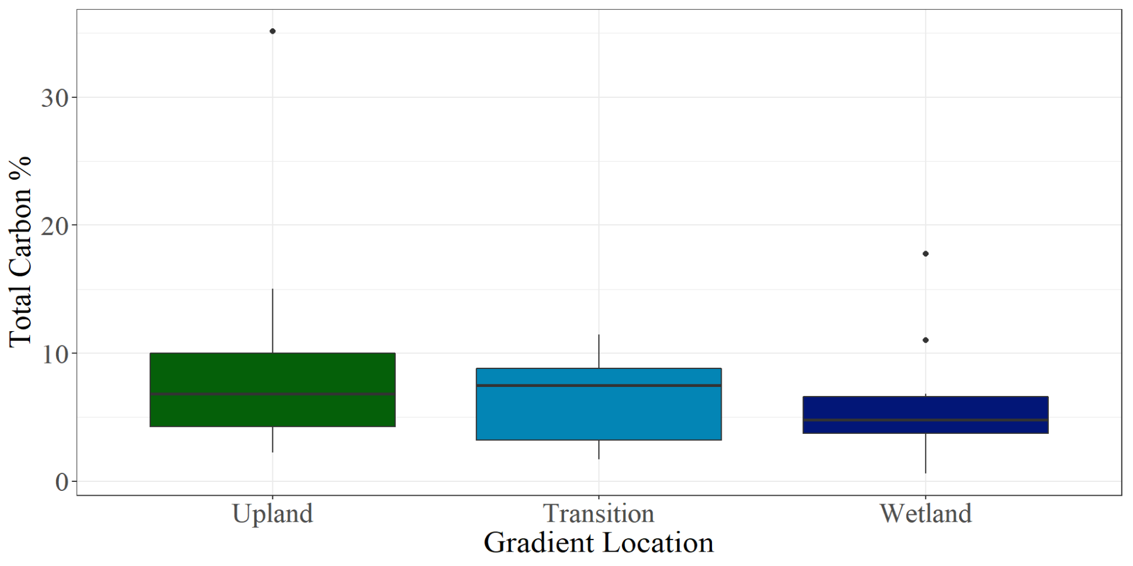

FIG. 6. Total carbon percentages of soils, by location on the TAI gradient. A Kruskal-Wallis test demonstrated that there was no significant difference in mean percentages between locations on the TAI gradient (χ2 = 0.84387, p = 0.6558).

REFERENCES

1 N.D. Ward, J.P. Megonigal, B. Bond-Lamberty, V.L. Bailey, D. Butman, E.A. Canuel, H. Diefenderfer, N.K. Ganju, M.A. Goñi, E.B. Graham, C.S. Hopkinson, T. Khangaonkar, J.A. Langley, N.G. McDowell, A.N. Myers-Pigg, R.B. Neumann, C.L. Osburn, R.M. Price, J. Rowland, A. Sengupta, M. Simard, P.E. Thornton, M. Tzortziou, R. Vargas, P.B. Weisenhorn, and L. Windham-Myers, Nature Communications 2020 11:1 **11**, 1 (2020).

2 A.C. Spivak, J. Sanderman, J.L. Bowen, E.A. Canuel, and C.S. Hopkinson, Nat Geosci **12**, 685 (2019).

3 P. Regier, N.D. Ward, J. Indivero, C. Wiese Moore, M. Norwood, and A. Myers-Pigg, Limnol Oceanogr Lett **6**, 134 (2021).

4 J.B. Kauffman, L. Giovanonni, J. Kelly, N. Dunstan, A. Borde, H. Diefenderfer, C. Cornu, C. Janousek, J. Apple, and L. Brophy, Glob Chang Biol **26**, 5679 (2020).

5 M.E. Mcclain, E.W. Boyer, C.L. Dent, S.E. Gergel, N.B. Grimm, P.M. Groffman, S.C. Hart, J.W. Harvey, C.A. Johnston, E. Mayorga, W.H. Mcdowell, and G. Pinay, (2003).

6 E.S. Bernhardt, J.R. Blaszczak, C.D. Ficken, M.L. Fork, K.E. Kaiser, and E.C. Seybold, Ecosystems **20**, 665 (2017).

7 N.D. Ward, T.S. Bianchi, P.M. Medeiros, M. Seidel, J.E. Richey, R.G. Keil, and H.O. Sawakuchi, Front Mar Sci **4**, 7 (2017).

8 K.A. Lohse, P.D. Brooks, J.C. Mcintosh, T. Meixner, and T.E. Huxman, Annual Review of Environmental and Resources **34**, 65 (2009).

9 N.S. Bolan, D.C. Adriano, A. Kunhikrishnan, T. James, R. McDowell, and N. Senesi, Advances in Agronomy **110**, 1 (2011).

10 S.E. Tank, J.B. Fellman, E. Hood, and E.S. Kritzberg, Limnol Oceanogr Lett **3**, 76 (2018).

11 V. Mangal, S. DeGasparro, D. v. Beresford, and C. Guéguen, Science of The Total Environment **704**, 135415 (2020).

12 M.H. Chantigny, Geoderma **113**, 357 (2003).

13 J.C. Neff and G.P. Asner, Ecosystems **4**, 29 (2001).

14 W.H. McDowell, Biogeochemistry 1 (2022).

15 T.W. Drake, P.A. Raymond, and R.G.M. Spencer, Limnol Oceanogr Lett **3**, 132 (2018).

16 J. Pages and F. Gadel, *DISSOLVED ORGANIC MATTER AND UV ABSORPTION IN A TROPICAL HYPERHALINE ESTUARY* (1990).

17 M.T. Brett, S.E. Bunn, S. Chandra, A.W.E. Galloway, F. Guo, M.J. Kainz, P. Kankaala, D.C.P. Lau, T.P. Moulton, M.E. Power, J.B. Rasmussen, S.J. Taipale, J.H. Thorp, and J.D. Wehr, Freshw Biol **62**, 833 (2017).

18 J.J. Cole, Y.T. Prairie, N.F. Caraco, W.H. Mcdowell, L.J. Tranvik, R.G. Striegl, C.M. Duarte, P. Kortelainen, J.A. Downing, J.J. Middelburg, and J. Melack, Ecosystems **10**, 171 (2007).

19 J. Lehmann and M. Kleber, Nature **528**, 60 (2015).

20 C.D. Gross and R.B. Harrison, Soil Systems 2019, Vol. 3, Page 28 **3**, 28 (2019).

21 M.A. Anthony, T.W. Crowther, D.S. Maynard, J. van den Hoogen, and C. Averill, One Earth **2**, 349 (2020).

22 P. Regnier, R. Lauerwald, and P. Ciais, Procedia Earth and Planetary Science **10**, 319 (2014).

23 T.K. Harms, P.M. Groffman, L. Aluwihare, C. Craft, W.R. Wieder, S.E. Hobbie, S.G. Baer, J.M. Blair, S. Frey, C.K. Remucal, J.A. Rudgers, and S.L. Collins, Climate Change Ecology **2**, 100025 (2021).

24 M. Nakhavali, R. Lauerwald, P. Regnier, B. Guenet, S. Chadburn, and P. Friedlingstein, Glob Chang Biol **27**, 1083 (2021).

25 A.K. Aufdenkampe, E. Mayorga, P.A. Raymond, J.M. Melack, S.C. Doney, S.R. Alin, R.E. Aalto, and K. Yoo, Front Ecol Environ **9**, 53 (2011).

26 P.A. Raymond and J.E. Saiers, Biogeochemistry **100**, 197 (2010).

27 H.F. Wilson, J.E. Saiers, P.A. Raymond, and W. v. Sobczak, Ecosystems **16**, 604 (2013).

28 P. Shang, Y.H. Lu, Y.X. Du, R. Jaffé, R.H. Findlay, and A. Wynn, Science of the Total Environment **612**, 1442 (2018).

29 T. Mattsson, P. Kortelainen, and A. Räike, Biogeochemistry 2005 76:2 **76**, 373 (2005).

30 J.H. Larson, P.C. Frost, M.A. Xenopoulos, C.J. Williams, A.M. Morales-Williams, J.M. Vallazza, J.C. Nelson, and W.B. Richardson, Ecosystems **17**, 1413 (2014).

31 S. Li, M. Li, G. Wang, X. Sun, B. Xi, and Z. Hu, Chem. Biol. Technol. Agric **6**, 20 (2019).

32 J.A. Aitkenhead and W.H. McDowell, Global Biogeochem Cycles **14**, 127 (2000).

33 P.D. Brooks, D.M. McKnight, and K.E. Bencala, Water Resour Res **35**, 1895 (1999).

34 M.R. Gmach, M.R. Cherubin, K. Kaiser, C.E. Pellegrino Cerri, and P.C. Sentelhas, Sci. Agric. v **77**, 2020 (2018).

35 T.J. Battin, L.A. Kaplan, S. Findlay, C.S. Hopkinson, E. Marti, A.I. Packman, J.D. Newbold, and F. Sabater, Nat Geosci **1**, 95 (2008).

36 B. SCAGLIA and F. ADANI, Journal of Environmental Sciences **21**, 641 (2009).

37 T. Rennert, K.F. Gockel, and T. Mansfeldt, Journal of Plant Nutrition and Soil Science **170**, 514 (2007).

38 K.M. Wardinski, E.R. Hotchkiss, C.N. Jones, D.L. McLaughlin, B.D. Strahm, and D.T. Scott, J Geophys Res Biogeosci e2022JG006994 (2022).

39 Y. Wang, Y. Hu, C. Yang, and Y. Chen, Science of The Total Environment **628–629**, 1249 (2018).

40 K. Wang, Y. Pang, Y. Li, C. He, Q. Shi, Y. Wang, and D. He, ACS Earth Space Chem **5**, 1102 (2021).

41 K.R. Murphy, C.A. Stedmon, D. Graeber, and R. Bro, Analytical Methods **5**, 6557 (2013).

42 A.M. Hansen, T.E.C. Kraus, B.A. Pellerin, J.A. Fleck, B.D. Downing, and B.A. Bergamaschi, Limnol Oceanogr **61**, 1015 (2016).

43 J.L. Weishaar, G.R. Aiken, B.A. Bergamaschi, M.S. Fram, R. Fujii, and K. Mopper, Environ Sci Technol **37**, 4702 (2003).

44 J.R. Helms, A. Stubbins, J.D. Ritchie, E.C. Minor, D.J. Kieber, and K. Mopper, Limnol Oceanogr **53**, 955 (2008).

45 E. Parlanti, K. Wörz, L. Geoffroy, and M. Lamotte, Org Geochem **31**, 1765 (2000).

46 T. Ohno, Environ Sci Technol **36**, 742 (2002).

47 D.M. McKnight, E.W. Boyer, P.K. Westerhoff, P.T. Doran, T. Kulbe, and D.T. Andersen, Limnol Oceanogr **46**, 38 (2001).

48 J. Huang and C. Song, **60**, 182 (2009).

49 X.Z. Ma, L.J. Chen, Z.H. Chen, Z.J. Wu, L.L. Zhang, and Y.L. Zhang, *SOIL GLYCOSIDASE ACTIVITIES AND WATER SOLUBLE ORGANIC CARBON UNDER DIFFERENT LAND USE TYPES* (2010).

50 A.G. Seifert, V.N. Roth, T. Dittmar, G. Gleixner, L. Breuer, T. Houska, and J. Marxsen, Science of The Total Environment **571**, 142 (2016).

51 S. Tao and B. Lin, Water Res **34**, 1751 (2000).

TABLES

**Table 1**

Water Soluble Organic Carbon and Dissolved Organic Carbon Concentrations by Gradient Point, Averaged Across All Study Sites

|  |  |  |  |  |  |
| --- | --- | --- | --- | --- | --- |
|  | **WSOC Concentration (mg/g soil)** | | | **DOC Concentration (mg/L)** | |
| **TAI Gradient Point** | Great Lakes  (n=3) | Mid-Atlantic (n=7) | Great Lakes (n=3) | | Mid-Atlantic  (n=7) |
| Upland | 0.836 ± 0.256 | 1.460 ± 0.600 | --- | | --- |
| Transition | 0.574 ± 0.275 | 0.783 ± 0.210 | --- | | --- |
| Wetland | 1.036 ± 0.661 | 1.075 ± 0.438 | --- | | --- |
| Surface Water | --- | --- | 7.383 ± 0.092 | | 4.936 ± 0.584 |

Note: Results are reported as mean ± standard error.

**Table 2**

Organic Matter Composition Metrics by Gradient Point, Averaged Across All Ten Study Sites

|  |  |  |  |  |  |
| --- | --- | --- | --- | --- | --- |
| **TAI Gradient Point** | SUVA254  (L/mg C·m) | S350-400 | FI | FRESH | HIX |
| Upland | 1.83 ± 0.19 | 0.0187 ± 0.0005 | 1.45 ± 0.04 | 0.444 ± 0.016 | 1.09 ± 0.07 |
| Transition | 1.80 ±0.12 | 0.0194 ± 0.0005 | 1.52 ± 0.02 | 0.470 ± 0.015 | 1.06 ± 0.03 |
| Wetland | 1.14 ± 0.13 | 0.0214 ± 0.0007 | 1.62 ± 0.02 | 0.593 ± 0.024 | 0.99 ± 0.08 |
| Surface Water | 3.45 ± 0.24 | 0.0163 ± 0.0006 | 1.61 ± 0.02 | 0.733 ± 0.027 | 0.87 ± 0.01 |
|  |  |  |  |  |  |
| Kruskal-Wallis Test Results | χ2 = 26.516  p = 7.438 x 10-6 | χ2 = 21.501  p = 8.285 x 10-5 | χ2 = 16.395  p = 9.411 x 10-4 | χ2 = 29.911  p = 1.441 x 10-6 | χ2 = 15.212  p = 0.00164 |

Note: Results are reported as mean ± standard error. Kruskal-Wallis tests were used to determine if gradient location had a significant effect on the values of each of the spectral metrics (df = 3). Post-hoc Dunn test results are visualized in Fig. 4.

1. COMPASS (Coastal Observations, Mechanisms, and Predictions Across Spatial Scales) is a multi-institutional program led by PNNL and funded by the Earth and Environmental Systems Science Division of the U.S. Department of Energy’s Office of Science.